Machrihanish Seabird Observatory (MSBO)
February Records 2014

Compiled by Eddie Maguire (warden)

Summary of the month...
- What an astonishing month! A first-winter American Herring Gull (Larus smithsonianus) was discovered in South Kintyre.
The bird was initially identified on floodwater by Kilmichael, just 2 miles NW of Campbeltown, on 6th / 7th (photographed) and then appeared almost daily in and around Campbeltown 15^{th –} 28th (photographed). It was particularly obliging when loafing on Campbeltown harbour and photographed down to a couple of metres! (All details / photos in this report).
This is the second record for Argyll (a first-winter bird was on Tiree March-May 2007) and the second ever Scottish mainland occurrence of this species.
Further intrigue followed this record with the news of a putative third-winter at Bruntholme, The Laggan (photographed) on 23rd.

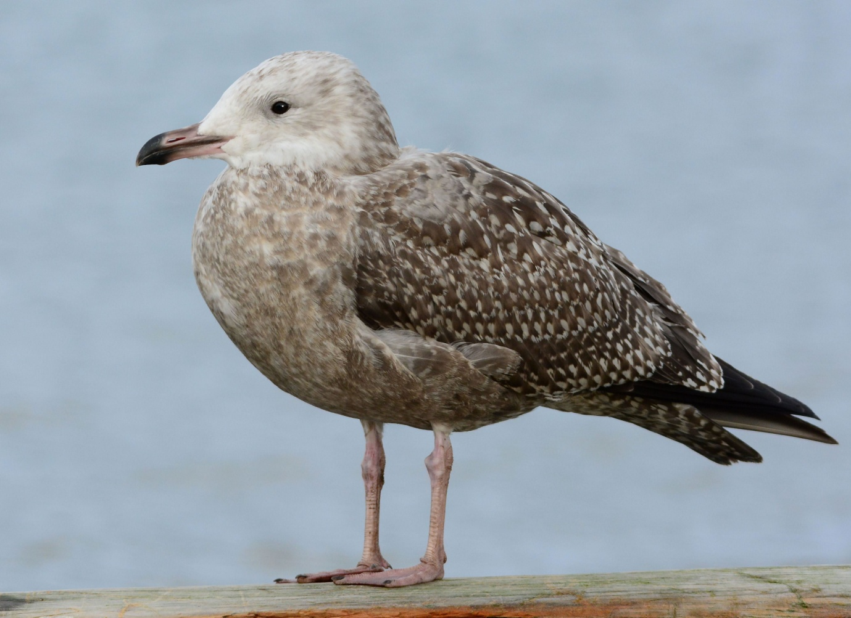
Machrihanishbirdobervatory.org.uk photograph of the month
First-winter American Herring Gull / Campbeltown Harbour – Eddie Maguire
Quote from Martin Garner (BBRC member) on Birding Frontiers website as follows...

“A first-winter smithsonianus beauty”
- An adult Yellow-legged Gull was identified by Drumlemble but flew off before it could be photographed. However, it was promptly relocated just S of Drumlemble School and photographed. If accepted by Scottish Birds Records Committee this will be the first record for Kintyre and the second Argyll occurrence.
Iceland Gull featured well at The Laggan with a first-winter, two regular second-winters and first and third-winter Kumlien’s.
Glaucous Gull was unusually scarce with only a single adult near Glenbarr and at least 4 Little Gulls were at Rhunahaorine Point.
Other rarities included 4 tundra Bean Geese and a Todd’s Canada Goose at The Laggan and a Little Auk was seen off Glenbarr.
A Magpie, very ‘popular’ with local folk, was seen frequently in Campbeltown and, off MSBO, a first-winter Northern Gannet was an unprecedented occurrence.
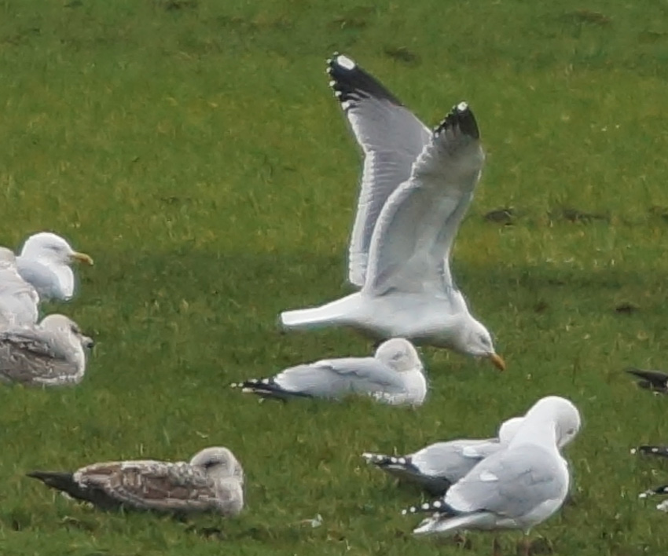
A likely first for Kintyre / Yellow-legged Gull – Jim Dickson

Selected Species List
Bean Goose
Four tundra (race rossicus) were by Kilmichael on 22nd (Tim Cowley, Eddie Maguire et al) and at Rhoin farm (1mile NW of Kilmichael) on 23rd (Eddie Maguire).
Two were with Greylags by Campbeltown Airport on 26th (Paul Brooks) and 4 were by Kilmichael on 27th (Eddie Maguire).
A very rare visitor.
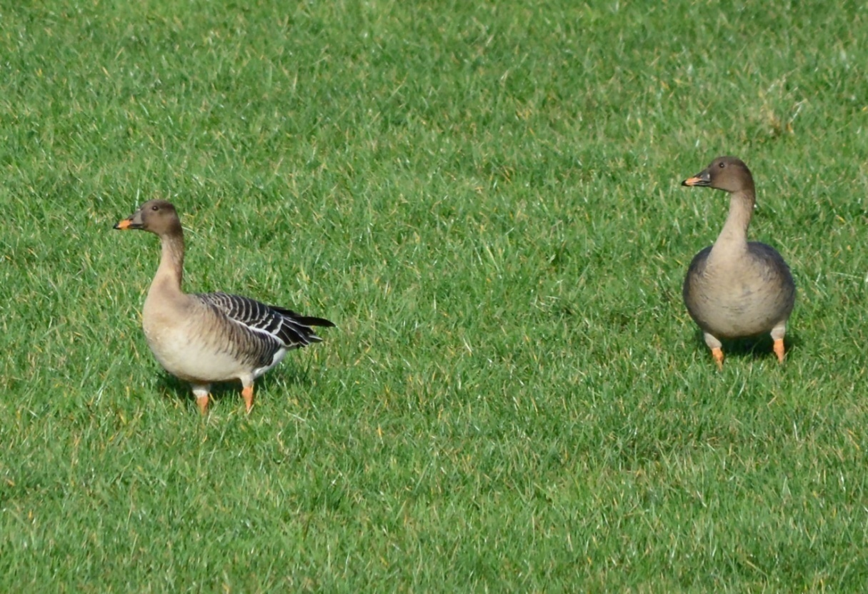 Tundra Bean Geese / Rhoin Farm (NE Laggan) – Eddie Maguire

Pink-footed Goose
Four (with Greylags) by Kilmichael (2 miles NW of Campbeltown) on 11th (Eddie Maguire). Two were at East Chiscan on 18th (Dan Brown / Tom Lowe pers. comm.).
Five by Kilmichael on 22nd (Eddie Maguire / Tim Cowley).
A regular winter visitor, usually in very small numbers.

White-fronted Goose
A total of 1320 at East Chiscan on 18th (Dan Brown / Tom Lowe pers. comm.).

Greylag
Flock 360 at Kilmichael on 11th. Three flocks between Kilmichael and East Chiscan on 28th totalled 620 birds.

Canada Goose
Flock 129 ‘large’ birds by East Darlochan (3 miles NW of Campbeltown) on 12th.
This is the second winter in a row that numbers have appeared at The Laggan.
A Todd’s Canada Goose was Aros Moss, The Laggan on 18th (Dan Brown / Tom Lowe pers. comm.).
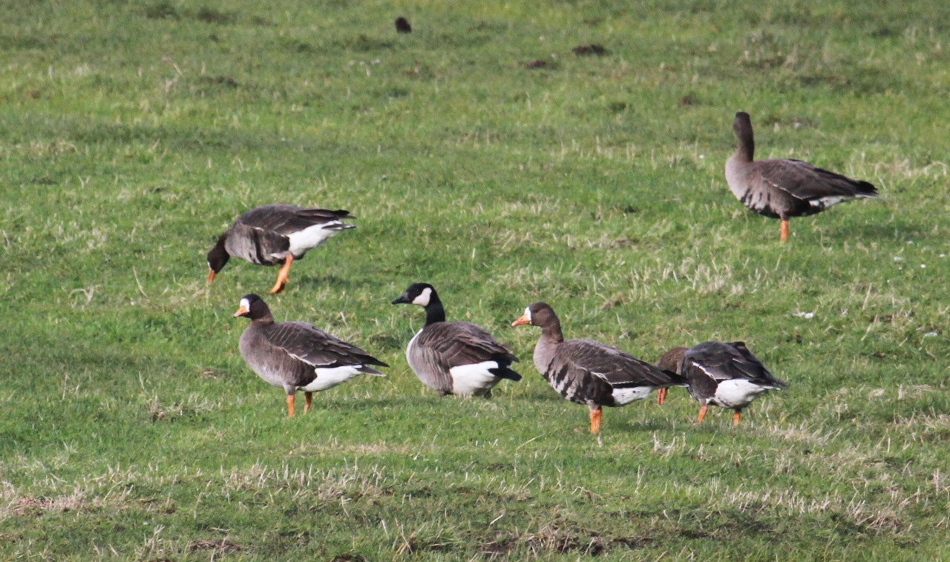
Todd’s Canada Goose – Dan Brown

Barnacle Goose
Two at Kilmichael on 22nd.

Shelduck
Flock 16 on floodwater between The Moy and E Backs on 22nd.

Wigeon
Flock 370 on floodwater at Kilmichael on 11th.
Flock 178 on floodwater at E Chiscan on 12th.

Teal
Flock 56 on floodwater at E Chiscan, The Laggan on 12th.

Pintail
A pair on floodwater at Kilmichael on 22nd.

Shoveler
E Chiscan floodwater: a drake 21st / 22nd with 3 (2 ducks) there on 22nd.

Tufted Duck
E Chiscan floodwater: four including 3 drakes on 21st. A drake and a duck still present on 22nd / 24th and 4 on 25th including 2 drakes.
This is a good showing for Kintyre.

Eider
Flock 129 Campbeltown inner harbour on 12th included 76 adult males.
An adult drake, initially identified as a Northern Eider, was swiftly found to be lacking all soft part characteristics of this race (borealis): it was photographed at Campbeltown harbour on 25th (Eddie Maguire) and still there on 28th (John Nadin).
Good looking bird with poor credentials!
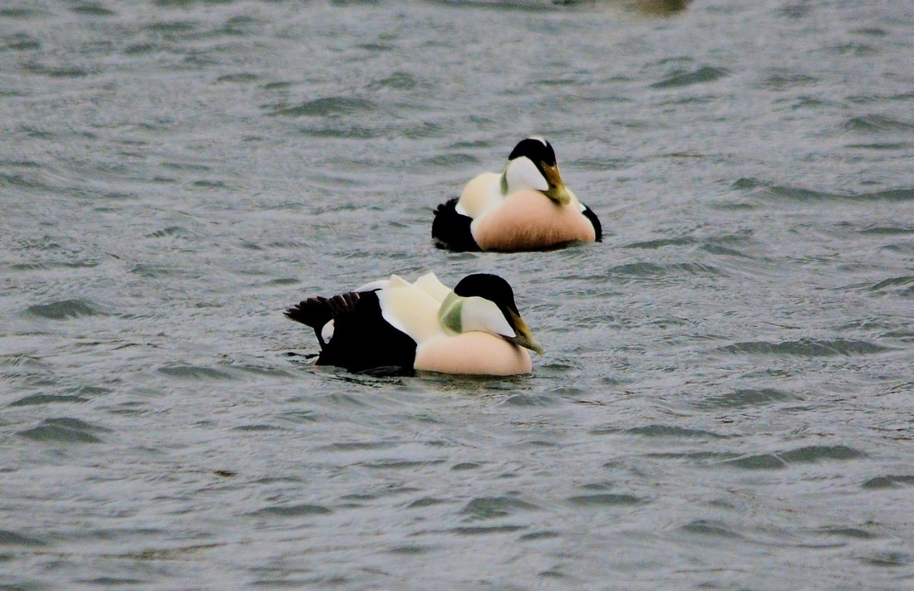
Eider displaying a single plumage feature of race borealis / note ‘sails’ on back - Eddie Maguire

Long-tailed Duck
A female-type on 6th, 8th and 15th.
Probably the same bird present off MSBO and Machrihanish village since November but has only been seen intermittingly.

Goldeneye
Flock 22 off MSBO on 12th included 15 adult males.

Common Scoter
A female Campbeltown Harbour 16th – 27th.
An unusual visitor here.

Red-throated Diver
Total of 5 >S on 9th. One >S on 11th. One’s and two’s were regular offshore.

Black-throated Diver
One on 6th.

Great Northern Diver
The best count was only 13 on 11th.

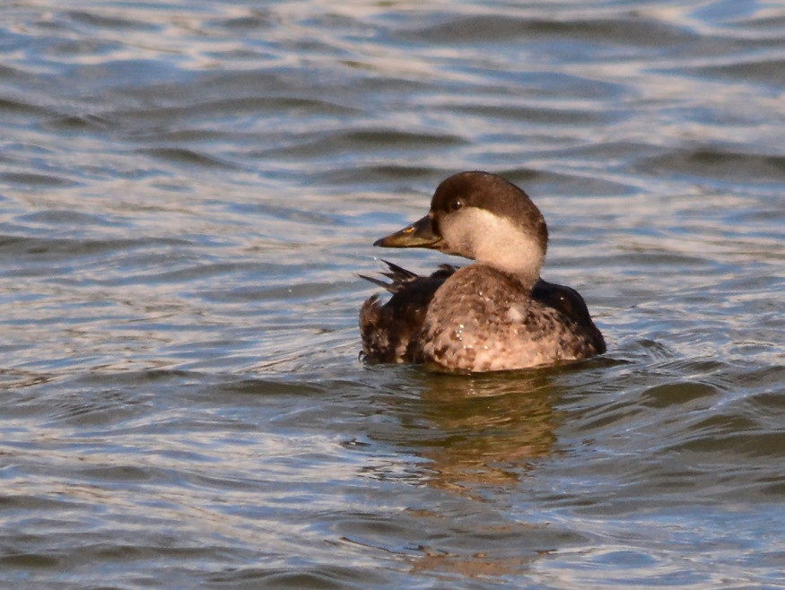
Common Scoter / Campbeltown Harbour – Eddie Maguire

Northern Gannet
A first-winter was photographed >N on 8th.
A remarkable occurrence. Apparently there are no previous winter records of this age category for the county (see Birds of Argyll).
A first-winter was also reported in Moray and Nairn on 2nd February 2014 (Angus Murray / Birdline Scotland pers. com.).
A ‘totally brown Gannet’ (6 adults also present) was seen at the stern of a trawler in the Kilbrannan Sound off Campbeltown Loch on 15th (Martin Morrison pers. com.).

Hen Harrier
Ringtails: one at West Parkfergus on 14th.
Males: one at Aros Moss on 10th.

Lapwing
The only record at MSBO was 5 >S on 20th.
E Chiscan floodwater: c. 40 on 21st.

Sanderling
One on 6th. Six >S on 20th.

Purple Sandpiper
Flocks 8 on 11th and 10 on 27th.

Turnstone
Flock 18 on 16th.

Black-legged Kittiwake
Total of 470 >S / 5hrs off MSBO on 9th. Age category samples revealed c. 20% first-winter.
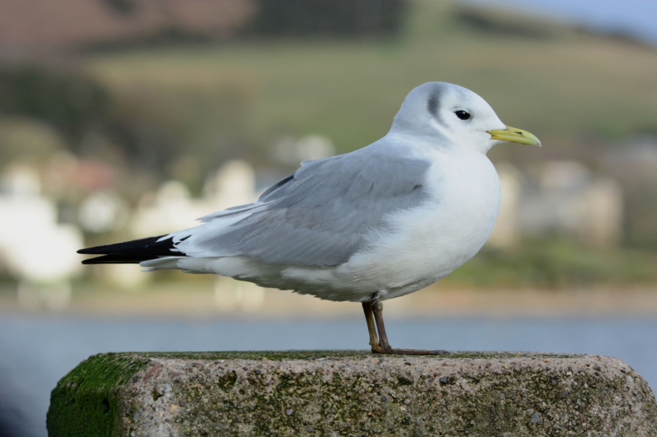
Adult Black-legged Kittiwake / Campbeltown Harbour – Eddie Maguire

Little Gull
A first-winter was just N of Rhunahaorine Point, Tayinloan on 16th (Keith Hoey / Dave Abraham) and an adult and 3 first-winters were there on 25th (Andy Robinson).
A remarkable multiple occurrence of a scarce winter visitor.

Lesser Black-backed Gull
An adult >S on 20th (first sign of passage this year). Three adults by Drumlemble on 21st with at least 6 in The Laggan the following day including a second-winter. A loose group of 7 >E at Drumlemble on 24th. Five were by Campbeltown Airport on 26th.

American Herring Gull
A first–winter was found on floodwater between Kilmichael and Dhurrie Farm (seen from A83 ca. 2 miles NW of Campbeltown) on 6th (Dan Brown) and seen again there / photographed on 7th (Jim Dickson pers. comm.).
Then, on 15th, it was discovered / photographed at Campbeltown Harbour (Eddie Maguire).
Further sightings included...
- 16th and 20th – Campbeltown Harbour (Eddie Maguire / Birdguides).
- 21st – in a field just W of Campbeltown (Dan Brown).
- 22nd – The Moy 1 mile W of Campbeltown (Bob Swan / Alastair McNee / Tim Cowley / Eddie Maguire)
- 28th – Kilmichael (Angus McNab / John Nadin et al).
- 1st March – Campbeltown Loch at dawn and later at Kilmichael (Bert Mitchell / Mark Rayment / Dave Webb).

In addition, a possible third-winter was photographed at Bruntholme on 23rd (Dan Brown).

Note: the first-winter individual constitutes a new species in Kintyre / second Argyll record and second Scottish mainland occurrence.

Many birders (100+.) travelled to Campbeltown 7th February – 1st March to connect with this celebrity: unfortunately, the majority were unsuccessful.
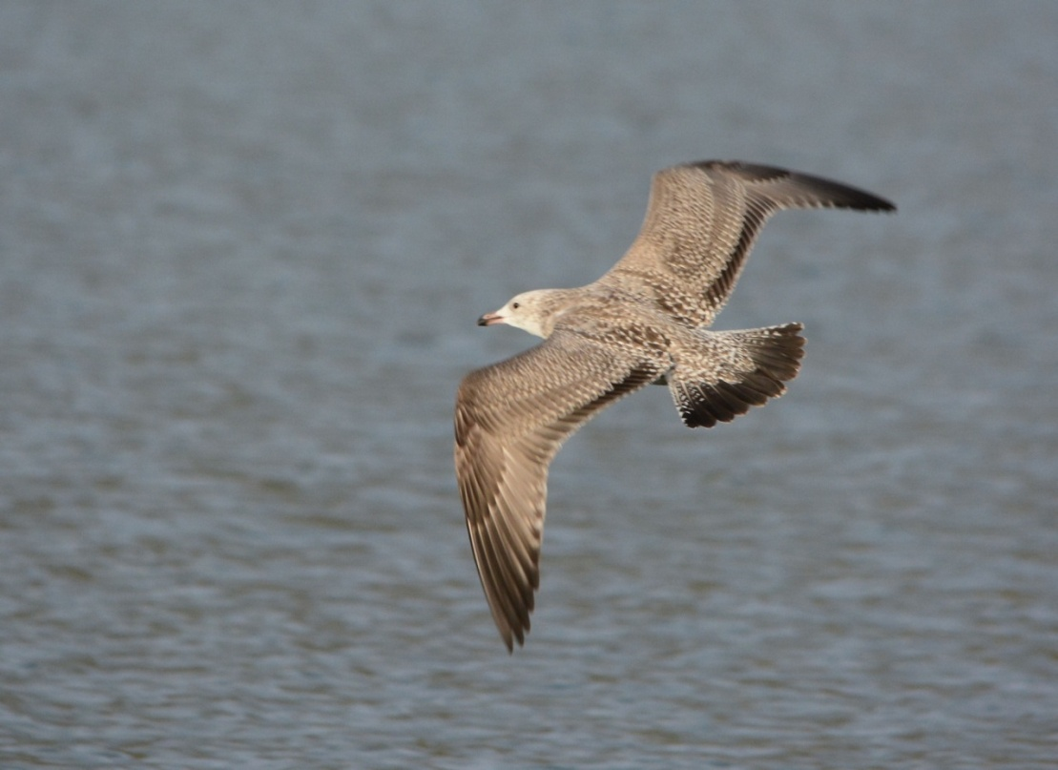
First-winter American Herring Gull / Campbeltown harbour – Eddie Maguire

Yellow-legged Gull
An adult was identified / photographed by Drumlemble on 21st (Jim Dickson / Eddie Maguire) and 22nd (Eddie Maguire / Tim Cowley).
This is another new species in Kintyre and the second Argyll record.
It seems likely that this extremely rare occurrence is connected to the very recent commencement of Lesser Black-backed Gull passage N through Kintyre.

Iceland Gull
Two second-winters were found on 18th; one at Kilmichael and the other at East Backs, The Laggan (Tom Lowe / Dan Brown pers. comm.):
These birds were seen regularly at various locations in The Laggan 19th-27th (Eddie Maguire / Jim Dickson / Tim Cowley et al). A first-winter appeared on 28th (Jim Dickson). A *first-winter Kumlien’s Gull was at Drumlemble on 18th and a third-winter was at East Backs, The Laggan the same day (Dan Brown / Tom Lowe pers. comm.): the latter individual was photographed nearby at The Strath on 19th (Eddie Maguire). A *first-winter was by Drumlemble on 21st (Jim Dickson / Eddie Maguire), *22nd (Eddie Maguire / Tim Cowley). Both were seen regularly to 28th (Eddie Maguire / John Nadin et al).
*This is a distinctively pale individual / considered to be the same bird that was photographed by MSBO last month (see photograph in MSBO January Report).

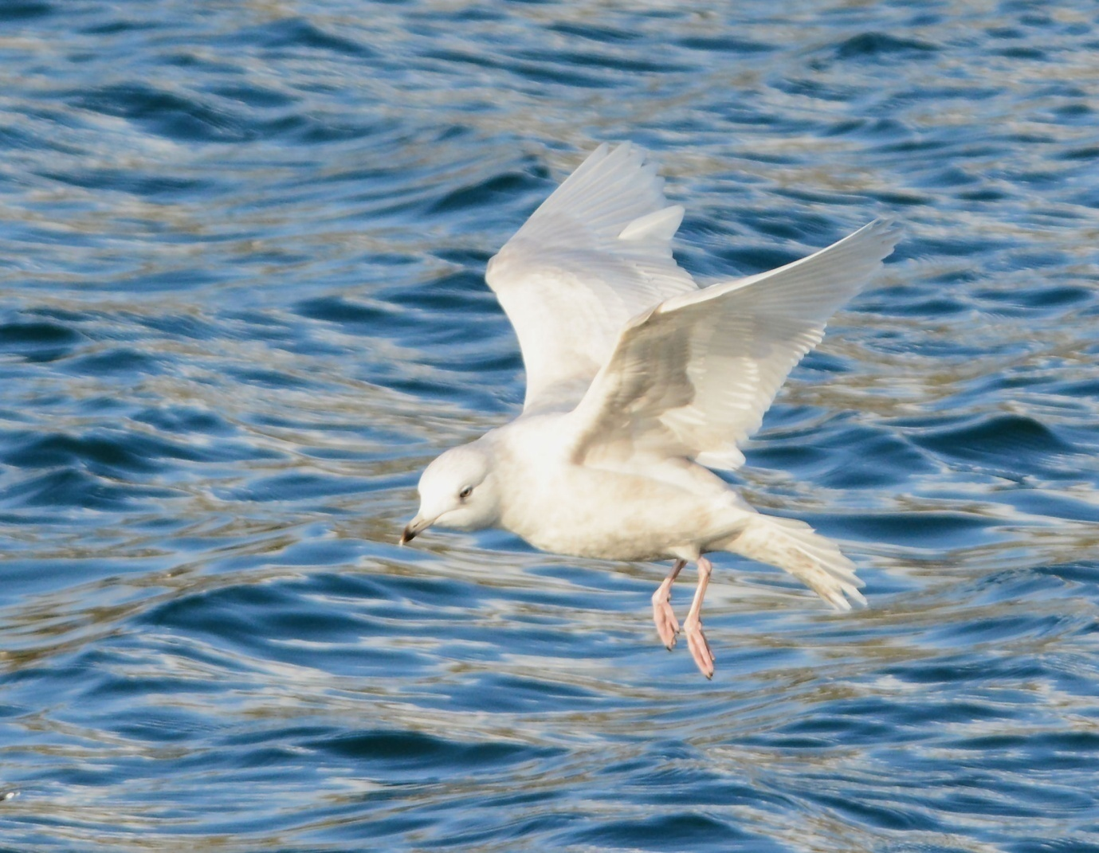
Second-winter Iceland Gull / Campbeltown harbour – Eddie Maguire

Glaucous Gull
An adult was just S of Barr Water mouth, near Glenbarr on 7th and 10th (Jim Dickson pers. comm.).
This species has been conspicuously scarce this winter.

Razorbill / Guillemot
In many flights monitored in and out of Machrihanish Bay, Razorbills far outnumbered Guillemots (14/1). A small number of both species were in breeding plumage from the beginning of the month.
Ten Razorbills were found dead on the small sandy beach just W of Southend on 24th (Donnie McLean).

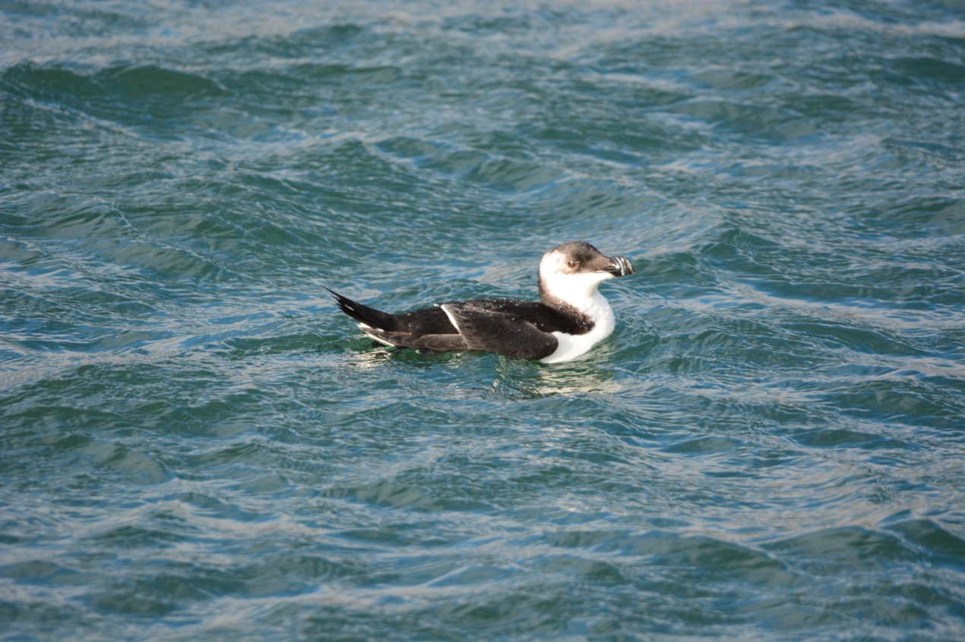
Razorbill – Eddie Maguire

Little Auk
One was reported off Glenbarr on 10th (Jim Dickson pers. comm.).

Magpie
One was seen often between Stronvar Bowling Club and the Grammar School Campbeltown (Bob Middleton et al).

Starling
C. 2000 at Drumlemble on 11th.
C. 900 by MSBO on 13th.

Other wildlife news...

Otter
Seen on 6 dates and photographed several times.

Pipistrelle
One was active at dusk over Argyll St, Campbeltown on 15th.

Bumble
A queen Bombus lacorum entered MSBO on 18th:
This was a bright, sunny day and the temperature was fairly high, especially am. Also, there was an amazing amount of flying insects over rotten seaweed on the shore (probably hatching kelp fly larvae).

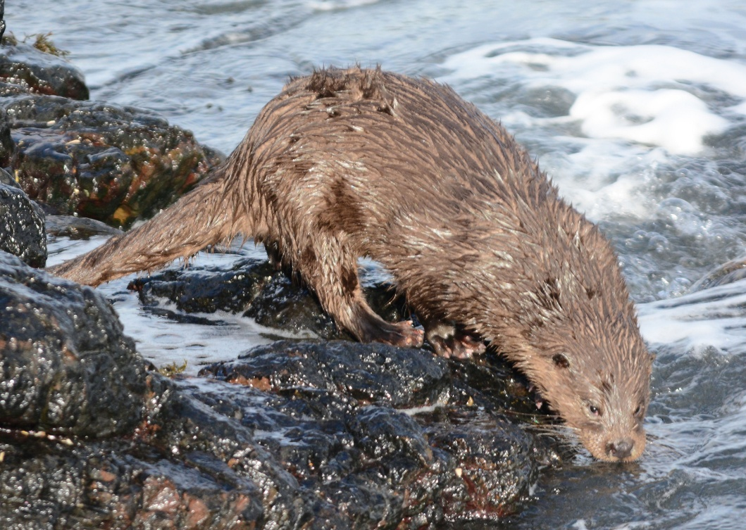
Otter by MSBO – Eddie Maguire

